WEEK:3 -SPRING CORE AND MAVEN

Exercise 1: Configuring a Basic Spring Application Scenario:

Scenario:
Your company is developing a web application for managing a library. You need to use the Spring Framework to handle the backend operations.
Steps:
- Set up a Maven project named LibraryManagement.
- Add Spring Core dependencies in the pom.xml file.
- Create an XML configuration file named applicationContext.xml in the src/main/resources directory.
- Define beans for BookService and BookRepository in the XML configuration file.
- Create the BookService and BookRepository classes.
- Create a main class to load the Spring context and test the configuration.
- Run the application and verify the output.

SOLUTION:
pom.xml
<project xmlns="http://maven.apache.org/POM/4.0.0"
xmlns:xsi="http://www.w3.org/2001/XMLSchema-instance"
xsi:schemaLocation="http://maven.apache.org/POM/4.0.0
http://maven.apache.org/xsd/maven-4.0.0.xsd">
<modelVersion>4.0.0</modelVersion>
<groupId>com.library</groupId>
<artifactId>LibraryManagement</artifactId>
<packaging>jar</packaging>
<version>1.0-SNAPSHOT</version>
<name>LibraryManagement</name>
<dependencies>
<dependency>
<groupId>org.springframework</groupId>
<artifactId>spring-context</artifactId>
<version>5.3.36</version>
</dependency>
<dependency>
<groupId>junit</groupId>
<artifactId>junit</artifactId>
<version>4.13.2</version>
<scope>test</scope>
</dependency>
</dependencies>
<build>
<plugins>
<plugin>
<groupId>org.codehaus.mojo</groupId>
<artifactId>exec-maven-plugin</artifactId>
<version>3.1.0</version>
<configuration>
<mainClass>com.library.main.MainApp</mainClass>
</configuration>
</plugin>
</plugins>
</build>
</project>
MainApp.java
package com.library.main;
import com.library.service.BookService;
import org.springframework.context.ApplicationContext;
import org.springframework.context.support.ClassPathXmlApplicationContext;
public class MainApp {
public static void main(String[] args) {
ApplicationContext context =
new ClassPathXmlApplicationContext("applicationContext.xml");

BookService bookService =
(BookService) context.getBean("bookService");
bookService.addBook("Clean Code");
}
}
BookService.java
package com.library.service;
import com.library.repository.BookRepository;
public class BookService {
private BookRepository bookRepository;
public void setBookRepository(BookRepository bookRepository) {
this.bookRepository = bookRepository;
}
public void addBook(String bookName) {
System.out.println("Adding book: " + bookName);
bookRepository.saveBook(bookName);
}
}
BookRepository.java
package com.library.repository;
public class BookRepository {
public void saveBook(String bookName) {
System.out.println("Book \"" + bookName + "\" saved to the database.");
}
}
applicationContext.xml
<?xml version="1.0" encoding="UTF-8"?>
<beans xmlns="http://www.springframework.org/schema/beans"
xmlns:xsi="http://www.w3.org/2001/XMLSchema-instance"
xsi:schemaLocation="
http://www.springframework.org/schema/beans
http://www.springframework.org/schema/beans/spring-beans.xsd">

<bean id="bookRepository"
class="com.library.repository.BookRepository" />
<bean id="bookService"
class="com.library.service.BookService">
<property name="bookRepository"
ref="bookRepository" />
</bean>
</beans>
AppTest.java
package com.library;
import org.junit.Test;
public class AppTest {
@Test
public void testApp() {
System.out.println("Test executed.");
}
}

OUTPUT:
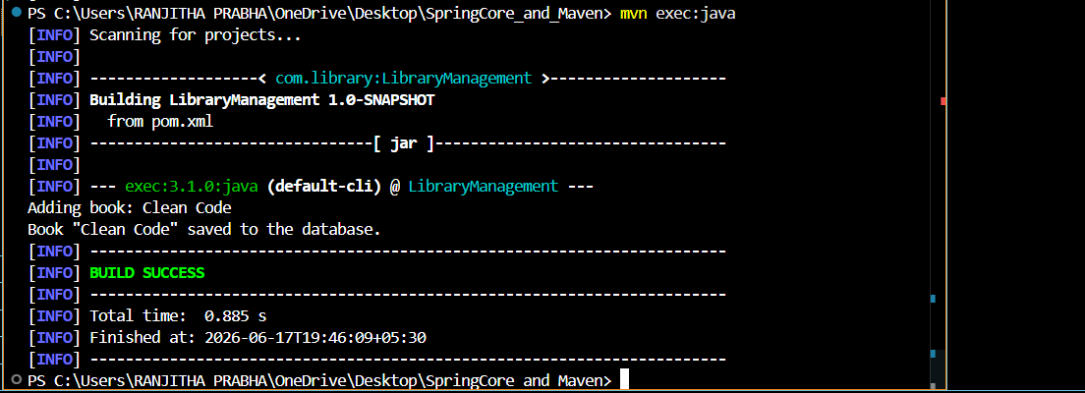

Exercise 2: Implementing Dependency Injection
Scenario:
In the library management application, you need to manage the dependencies between the BookService and BookRepository classes using Spring's IoC and DI.
Steps:
1. Modify the XML Configuration
- Open applicationContext.xml.
- Define beans for BookService and BookRepository.
- Inject the BookRepository bean into BookService using the property tag.
2. Update the BookService Class
- Create a private BookRepository variable.
- Add a setter method setBookRepository() for dependency injection.
3. Test the Configuration
- Load the Spring Application Context.
- Retrieve the BookService bean.
- Call the addBook() method to verify dependency injection.

SOLUTION
Use Spring’s Inversion of Control (IoC) to inject the BookRepository into BookService using an XML file (applicationContext.xml).
applicationContext.xml
<?xml version="1.0" encoding="UTF-8"?>
<beans xmlns="http://www.springframework.org/schema/beans"
xmlns:xsi="http://www.w3.org/2001/XMLSchema-instance"
xsi:schemaLocation="
http://www.springframework.org/schema/beans
http://www.springframework.org/schema/beans/spring-beans.xsd">
<bean id="bookRepository"
class="com.library.repository.BookRepository"/>
<bean id="bookService"
class="com.library.service.BookService">
<property name="bookRepository"
ref="bookRepository"/>
</bean>
</beans>
BookRepository.java
package com.library.repository;

public class BookRepository {
public void saveBook(String bookName) {
System.out.println("Book \"" + bookName + "\" saved to the database.");
}
}
BookService.java
package com.library.service;
import com.library.repository.BookRepository;
public class BookService {
private BookRepository bookRepository;
public void setBookRepository(BookRepository bookRepository) {
this.bookRepository = bookRepository;
}
public void addBook(String bookName) {
System.out.println("Adding book: " + bookName);
bookRepository.saveBook(bookName);
}
}
MainApp.java
package com.library.main;
import com.library.service.BookService;
import org.springframework.context.ApplicationContext;
import org.springframework.context.support.ClassPathXmlApplicationContext;
public class MainApp {
public static void main(String[] args) {
ApplicationContext context =
new ClassPathXmlApplicationContext("applicationContext.xml");
BookService bookService =(BookService) context.getBean("bookService");
bookService.addBook("Clean Code");
}
}
OUTPUT
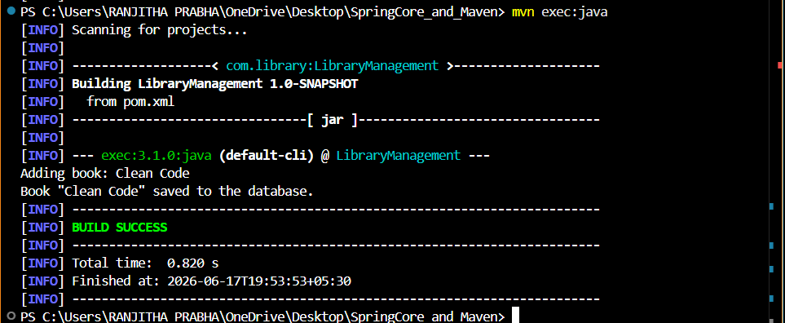

Exercise 4: Creating and Configuring a Maven Project
Scenario:
You need to set up a new Maven project for the library management application and add Spring dependencies.
Steps:
1. Create a New Maven Project
- Create a Maven project named LibraryManagement.
2. Add Spring Dependencies
- Add Spring Context dependency.
- Add Spring AOP dependency.
- Add Spring WebMVC dependency.
3. Configure Maven Plugins
- Configure Maven Compiler Plugin.
- Set source and target Java version to 1.8.
4. Build the Project
- Compile the project using Maven.
Solution Code :
pom.xml
<project xmlns="http://maven.apache.org/POM/4.0.0"
xmlns:xsi="http://www.w3.org/2001/XMLSchema-instance"
xsi:schemaLocation="http://maven.apache.org/POM/4.0.0
http://maven.apache.org/xsd/maven-4.0.0.xsd">

<modelVersion>4.0.0</modelVersion>
<groupId>com.library</groupId>
<artifactId>LibraryManagement</artifactId>
<version>1.0-SNAPSHOT</version>
<dependencies>

<!-- Spring Context -->
<dependency>
<groupId>org.springframework</groupId>
<artifactId>spring-context</artifactId>
<version>5.3.33</version>
</dependency>

<!-- Spring AOP -->
<dependency>
<groupId>org.springframework</groupId>
<artifactId>spring-aop</artifactId>
<version>5.3.33</version>
</dependency>

<!-- Spring WebMVC -->
<dependency>
<groupId>org.springframework</groupId>
<artifactId>spring-webmvc</artifactId>
<version>5.3.33</version>
</dependency>

<!-- JUnit -->
<dependency>
<groupId>junit</groupId>
<artifactId>junit</artifactId>
<version>4.13.2</version>
<scope>test</scope>
</dependency>
</dependencies>
<build>
<plugins>

<!-- Maven Compiler Plugin -->
<plugin>
<groupId>org.apache.maven.plugins</groupId>
<artifactId>maven-compiler-plugin</artifactId>
<version>3.8.1</version>
<configuration>
<source>1.8</source>
<target>1.8</target>
</configuration>
</plugin>

</plugins>
</build>
</project>

OUTPUT
